Table of contents

1. Table of contents
1. Table of contents 1
2. Data model 4 1
2.1. Model graphic: 1
2.2. Objects 1
2.2.1. Add_payment 1
2.2.2. Add_payment 1
2.2.3. Company 1
2.2.4. Create_date 1
2.2.5. Divisions 1
2.2.6. ID_company 1
2.2.7. ID_company 1
2.2.8. ID_division 1
2.2.9. ID_payroll 1
2.2.10. ID_payroll 1
2.2.11. ID_payroll 1
2.2.12. ID_paysheet 1
2.2.13. ID_person 1
2.2.14. ID_person 1
2.2.15. ID_person_sheet 1
2.2.16. ID_position 1
2.2.17. ID_position 1
2.2.18. ID_retention 1
2.2.19. ID_staff_list 1
2.2.20. ID_staff_list 1
2.2.21. ID_staff_list 1
2.2.22. Name 1
2.2.23. Name 1
2.2.24. Name 1
2.2.25. Name 1
2.2.26. Name 1
2.2.27. Number 1
2.2.28. OKPO 1
2.2.29. OKUD 1
2.2.30. Patronymic 1
2.2.31. Payrolls 1
2.2.32. Percent_of_bonus 1
2.2.33. Percent_of_cof 1
2.2.34. Person_sheets 1
2.2.35. Persons 1
2.2.36. Positions 1
2.2.37. Rate 1
2.2.38. Retentions 1
2.2.39. Salary 1
2.2.40. Staff_list 1
2.2.41. Surname 1
2.2.42. Type_retention 1

2. Data model 4

Model graphic:

2.1. Model graphic:
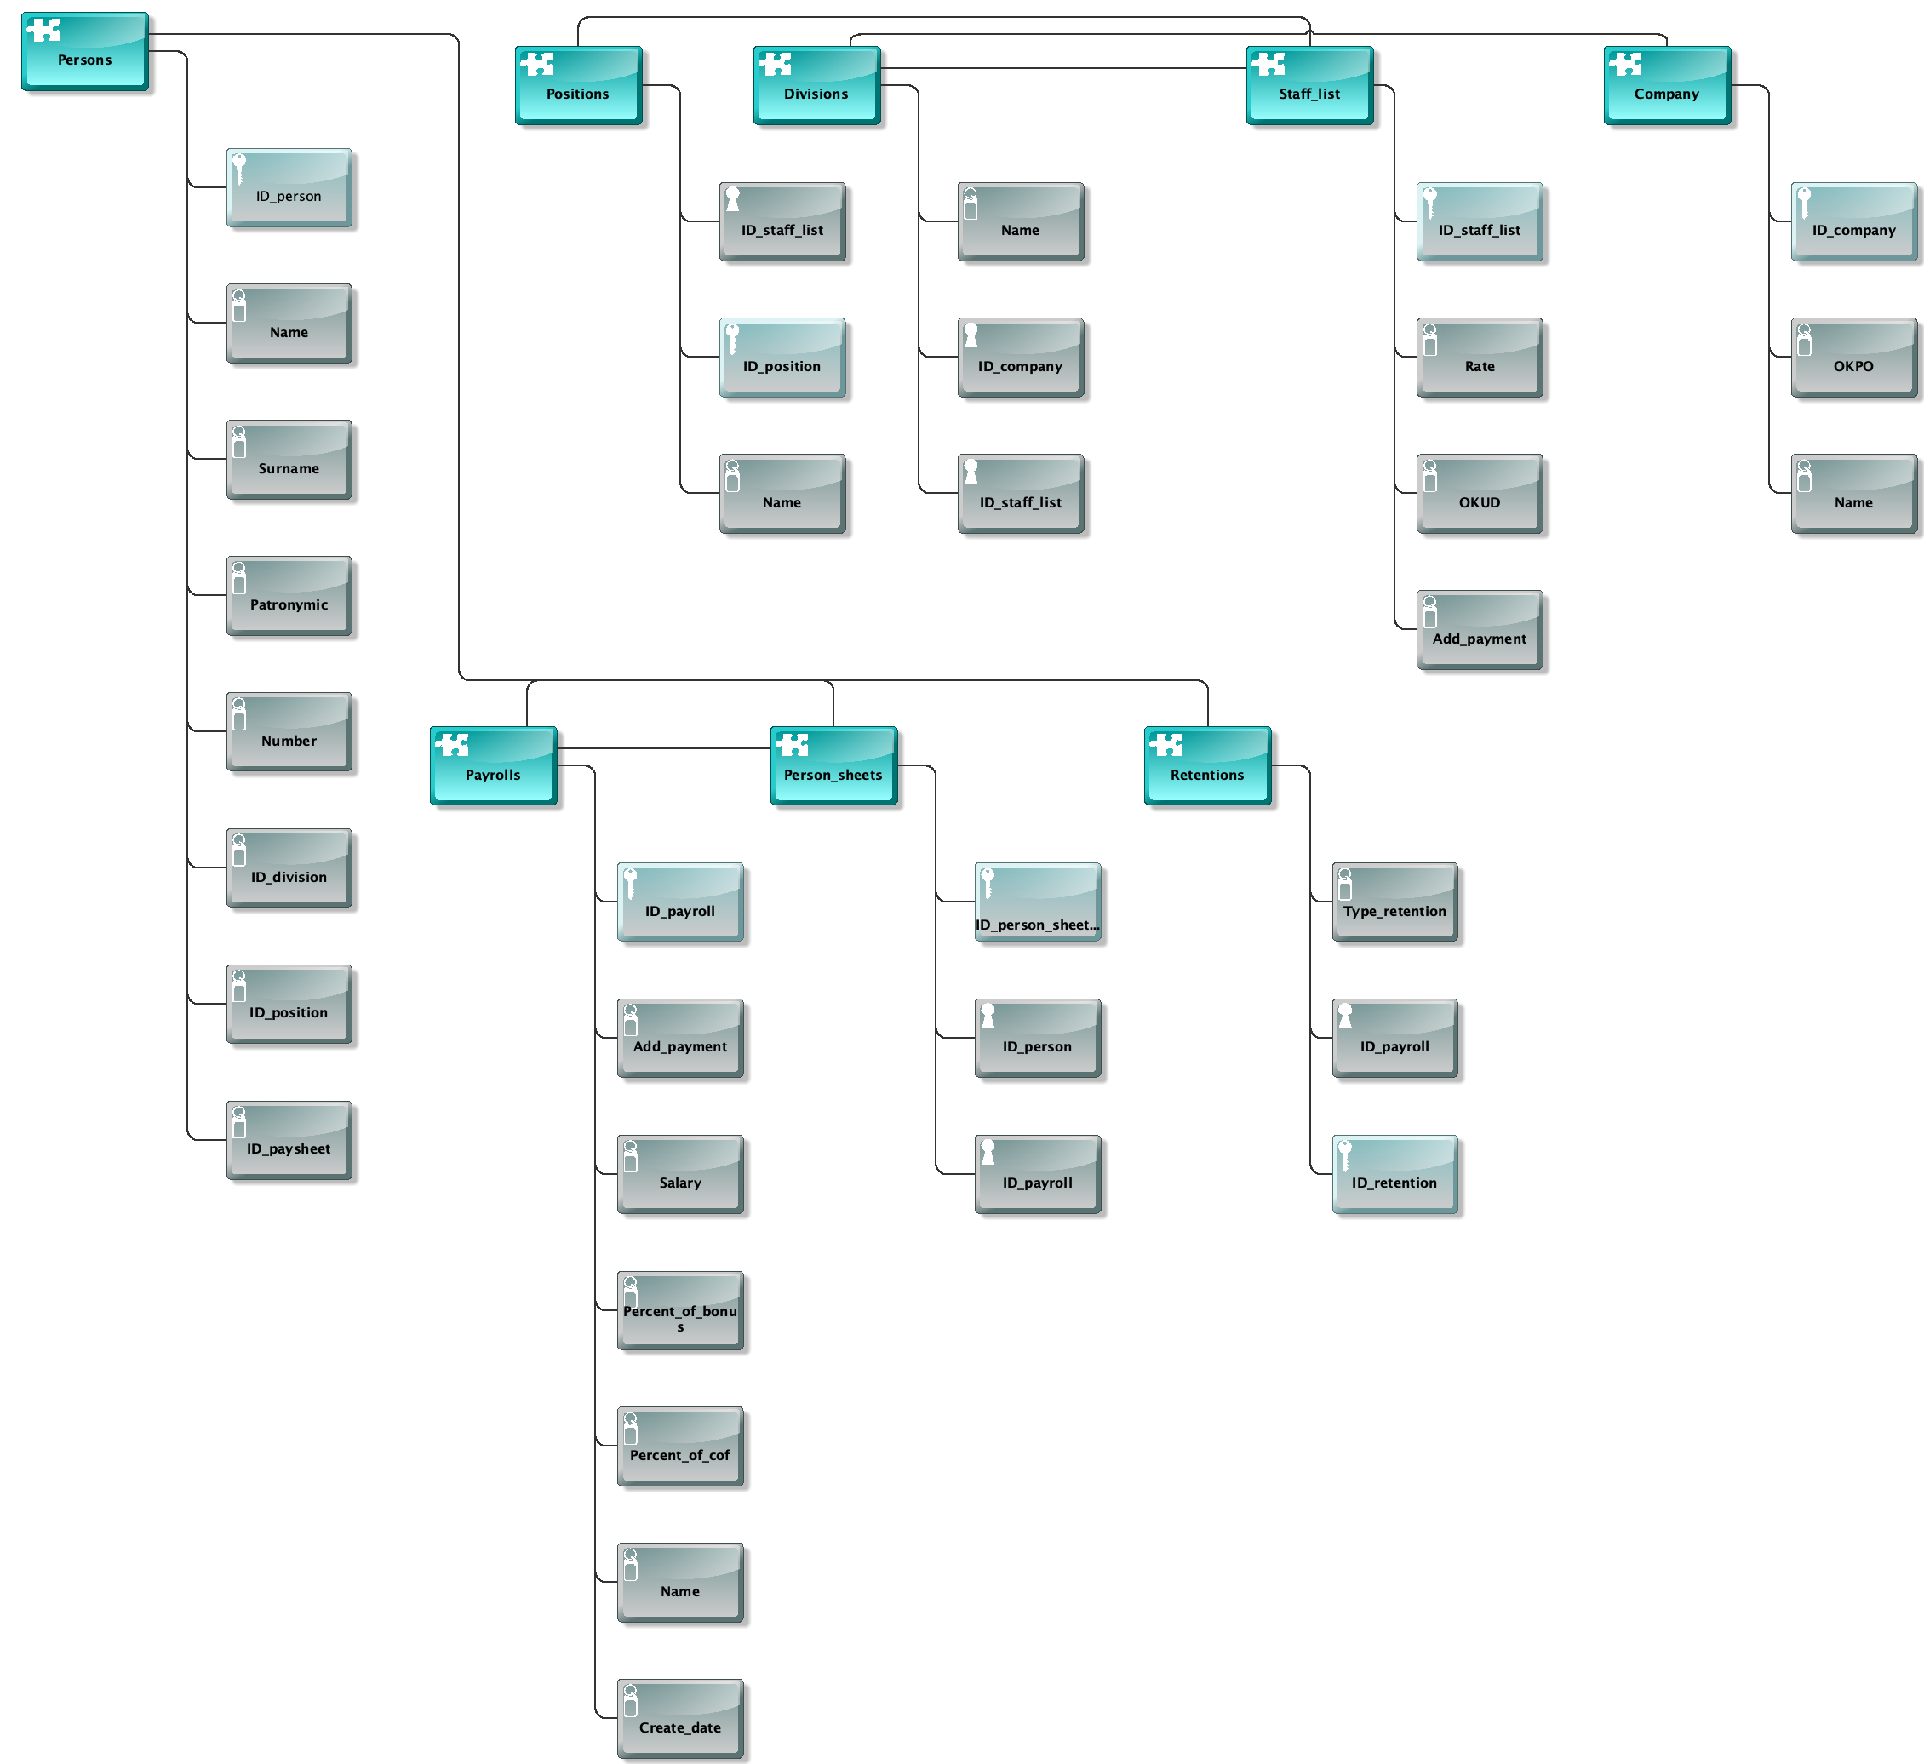

2.2. Objects

Objects

2.2.1. Add_payment
 | Add_payment
Description/Definition |  | Сумма надбавок

2.2.2. Add_payment
 | Add_payment
Description/Definition |  | Сумма надбавок

2.2.3. Company
 | Company

2.2.4. Create_date
 | Create_date
Description/Definition |  | Дата создания

2.2.5. Divisions
Divisions

2.2.6. ID_company
 | ID_company
Description/Definition |  | Код расписки

2.2.7. ID_company
 | ID_company
Description/Definition |  | Код предприятия

2.2.8. ID_division
 | ID_division
Description/Definition |  | Код подразделения

2.2.9. ID_payroll
 | ID_payroll
Description/Definition |  | Код расчетной ведомости

2.2.10. ID_payroll
 | ID_payroll
Description/Definition |  | Код расчетной ведомости

2.2.11. ID_payroll
 | ID_payroll
Description/Definition |  | Код расчетной ведомости

2.2.12. ID_paysheet
 | ID_paysheet
Description/Definition |  | Код платежной ведомости

2.2.13. ID_person
 | ID_person
Description/Definition |  | Код сотрудника

2.2.14. ID_person
 | ID_person
Description/Definition |  | Код сотрудника

2.2.15. ID_person_sheet
 | ID_person_sheet
Description/Definition |  | Код расчетного листа

2.2.16. ID_position
 | ID_position
Description/Definition |  | Код должности

2.2.17. ID_position
 | ID_position
Description/Definition |  | Код должности

2.2.18. ID_retention
 | ID_retention
Description/Definition |  | Тип удержания

2.2.19. ID_staff_list
 | ID_staff_list
Description/Definition |  | Код штатного расписания

2.2.20. ID_staff_list
 | ID_staff_list
Description/Definition |  | Код штатного расписания

2.2.21. ID_staff_list
 | ID_staff_list
Description/Definition |  | Код штатного расписания

2.2.22. Name
 | Name
Description/Definition |  | Наименования

2.2.23. Name
 | Name
Description/Definition |  | Имя

2.2.24. Name
 | Name
Description/Definition |  | Наименования

2.2.25. Name
 | Name
Description/Definition |  | Наименования

2.2.26. Name
 | Name
Description/Definition |  | Наименования

2.2.27. Number
 | Number
Description/Definition |  | Табельный номер

2.2.28. OKPO
 | OKPO
Description/Definition |  | ОКПО

2.2.29. OKUD
 | OKUD
Description/Definition |  | ОКУД

2.2.30. Patronymic
 | Patronymic
Description/Definition |  | Отчество

2.2.31. Payrolls
Payrolls

2.2.32. Percent_of_bonus
 | Percent_of_bonus
Description/Definition |  | Процент премии

2.2.33. Percent_of_cof
 | Percent_of_cof
Description/Definition |  | Районный коэффициент

2.2.34. Person_sheets
Person_sheets

2.2.35. Persons
Persons

2.2.36. Positions
Positions

2.2.37. Rate
 | Rate
Description/Definition |  | Тарифная ставка

2.2.38. Retentions
Retentions

2.2.39. Salary
 | Salary
Description/Definition |  | Сумма заработной платы

2.2.40. Staff_list
Staff_list

2.2.41. Surname
 | Surname
Description/Definition |  | Фамилия

2.2.42. Type_retention
 | Type_retention
Description/Definition |  | Код удержания

